**Convention used in this assignment :**

* Force towards the right = +ve
* Force towards the left = -ve
* Upward force = +ve
* Downward force = -ve
* Counter-Clockwise moment = +ve
* Clockwise moment = -ve

1.

(a)

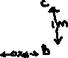

(b) Vertical component of tension(T) acting at C = Tsin70°= 0.939T

The horizontal component of tension(T) acting at C = -Tcos70°= -0.342T

(c) ΣFx = 0 equation: **HA – Tcos70° = 0 🡪 Eq.1**

ΣFy = 0 equation: **VA + Tsin70 – 2000 = 0 🡪 Eq.2**

(d) **MA = Tcos70x1 + Tsin70x2 – 2000x1.5 = 0 🡪 Eq.3**

(e) From Eq.1, we get

T(cos70 + 2sin70) = 3000

**T = 3000/(0.342 + 2x0.9397) = 1350.4997N**

(f) From Eq.1, HA = -TAcos70 = -1350.4997x0.342

**HA = -461.87N (Towards the right)**

From Eq.2, VA = 2000 – TAsin70 = 2000 – (1350.4997x0.9797)

= 2000 – 1269.0646

**VA = 730.9354N (Upwards)**

2.

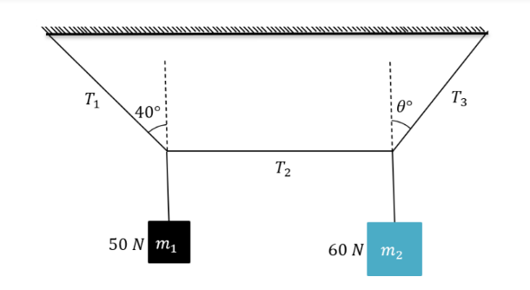(a)



1. **At B:**

Component of T1 in vertical direction (upwards) = T1cos40°

**= 0.766T1**

Component T1 in horizontal direction (towards left) = T1sin40°

**= 0.6428T1**

1. On m1:

Weight acting downward = w1 = -50N

Tension acting upward = 0.766T1 (From (b))

∴ **By vertical force equilibrium at B: 0.766T1 - 50 = 0 🡪 Eq. 1**

**The horizontal force equilibrium equation: T2 - 0.6428T1 = 0 🡪 Eq. 2**

1. From Eq. 1: 0.766T1 = 50

**T1 = 65.274N**

From Eq. 2: T2 = 0.6428T1

**T2 = 41.9582N**

1. Component of T3 in vertical direction = T3cosθ

Component of T3 in horizontal direction = T3sinθ

(e)On m2:

**Vertical force equilibrium equation at C: T3cosθ - 60 = 0 🡪 Eq. 3**

**Horizontal force equilibrium equation at C: T3sinθ - T2 = 0 🡪 Eq. 4**

(f)From Equations 3 and 4,

**T3cosθ = 60**

**T3sinθ = T2**

Dividing these 2 equations, we get

**cotθ = 60/T2**

**= 1.43**

**θ = cot-1(1.43) = 34.965°**

**(g)T3 = 60/cosθ**

**= 60/0.8195**

**= 73.2152N**